EDMI GS-60B
Information on how find your top up code and use this type of Smart PAYG meter.

How to enter your top up code
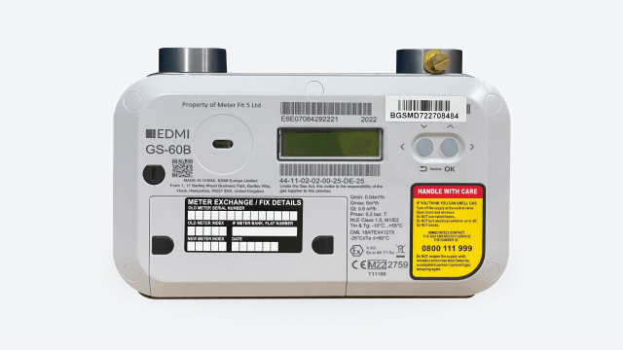

- Hold the right-hand button to wake the meter up.
- Press and hold the right-hand button to enter the menu.
- Press and hold the right-hand button to enter scroll to ‘Top up’.
- Hold the right hand button to enter the ‘Top up’ menu.
- Press and hold the right-hand button to scroll through the digits.
- Press and hold the right-hand button to enter the digit.
- When all digits are entered press and hold the right-hand button to enter the vend code and the meter will turn off.
- Press and hold the right-hand button to wake the meter.
- The vend is now on the meter.

How to turn your gas back on
First you need to check that there's nothing been left on that might be dangerous if your gas was to start up.
- Hold the right-hand button to wake the meter up.
- Once a display is shown press the right-hand button to scroll through the meter menu.
- When you reach the ‘enable’ screen press and hold the right-hand button.
- The screen will then change and ‘Enabled’ will appear.
- The supply will now be on.

How to activate Emergency Credit
- When emergency credit is available the screen will display Press Return for and emergency credit in rotation.
- To access the emergency credit, you need to press and hold the return button.
- This is the left hand button on the front of the meter it has a small return symbol underneath it.
- The screen will then display EC Remain and show you the amount activated.
- Emergency credit is now active on the meter.

