Landis + Gyr G370
Information on how find your top up code and use this type of Smart PAYG meter.

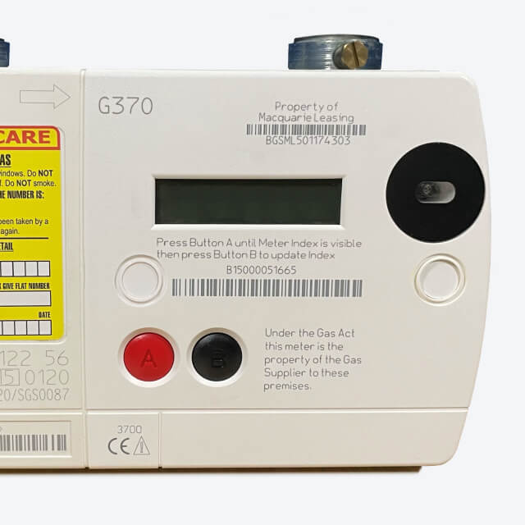

- Press A (red button) to wake the meter up.
- Press A again till you get to the screen that says, ‘Credit Entry,’ then press B (black button) for yes.
- Enter the first digit of your top up code/UTRN – press A to scroll through 0-9 until you get to the right number.
- Press button B when you're ready to move onto the next digit.
- Once you've entered all the numbers, press and hold button B for a few seconds to confirm your UTRN.
- The meter will then confirm the payment has been accepted.

How to turn your gas back on
First you need to check that there's nothing been left on that might be dangerous if your gas was to start up.
- Press and release the black B button.
- The screen will display the message ‘Appliances OFF? Hold A for Gas’.
- Press and hold the red A button until you see the message ‘Release A for gas’.
- Take your finger off the button and wait (this takes approximately 30 seconds.) The screen will then display ‘Please Wait... Opening Valve’.
- Once complete the screen will display the credit balance and the supply should now be reconnected.
- For safety, if the meter detects any gas flowing while turning back on it will turn itself off again until the flow is stopped. If this happens, please check all gas appliances to make sure there's nothing left on then try again from the start.

How to activate Emergency Credit
- When Emergency Credit is available you will see "EmCr Available" on your meter display.
- To access it, press and release the red A button until the display shows ""Accept EmCr?"
- Press button A and then button B to accept the Emergency Credit.
- When it has worked, you'll see that the display changes to show two lines. The top one tells you the balance (Credit or Owed) and the word "ON."
- The bottom line will show you how much Emergency Credit is left to use with "EmCr £xx.xx Rem".
- The top line will keep you updated on how much you need to repay to cover the Emergency Credit and any other charges that have built up (Standing Charge and if you're repaying a balance through your meter, the amount that would normally have been paid from your top up credits).

