Secure EG4V (10, 11 or 15)
Information on how find your top up code and use this type of Smart PAYG meter.

How to enter your top up code
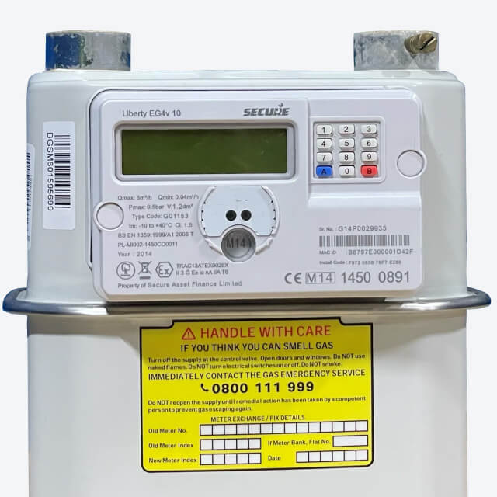
- Press the blue A button on your meter.
- You should see 'Vend Mode' on the display.
- Enter the entire top-up code/UTRN you got on your email, SMS or receipt.
- If you make a mistake, you can delete the last number by pressing the blue A button.
- Once you've entered all 20 digits, press the red B button on your meter.
- Your top-up transaction should now be processed and credited to your meter and you will see the word "Accepted".
- If you see another message; these are the possible reasons:
  - Rejected, Duplicate - Your top-up has already been credited to your meter.
  - Rejected, Incorrect - The top-up code has been entered incorrectly, please try again.
  - Rejected, Incomplete - You have not entered the entire top-up code and need to start again.
  - Rejected, Invalid - This means you could be at the wrong meter - check what meter the top-up is for - ie. electricity or gas meter, and ensure you are at that meter.

How to turn your gas back on
First you need to check that there's nothing been left on that might be dangerous if your gas was to start up.
- Press the blue A button. The meter will light up and the screen will say ‘PRESS A TO CONNECT’.
- Press A again and the meter will display ‘PRESS B TO CONFIRM’.
- Press the B button and the gas supply should now be reconnected.

How to activate Emergency Credit
- Press the "#" button on the keypad of your Liberty 100 or 110 Smart Meter until you see the "EC" or "emergency credit" display.
- The display will show you the amount of emergency credit available to you. Press the "A" button to confirm that you want to use the emergency credit.
- Once you have confirmed that you want to use the emergency credit, the meter will automatically add the credit to your balance.
- The amount of emergency credit available to you will be deducted from your next top-up. You will also be charged a daily standing charge for the use of the emergency credit, which will be deducted from your meter balance.

